Name: Arpit Mahalle
Day 26 Assignment output screenshots

Challenge 1:
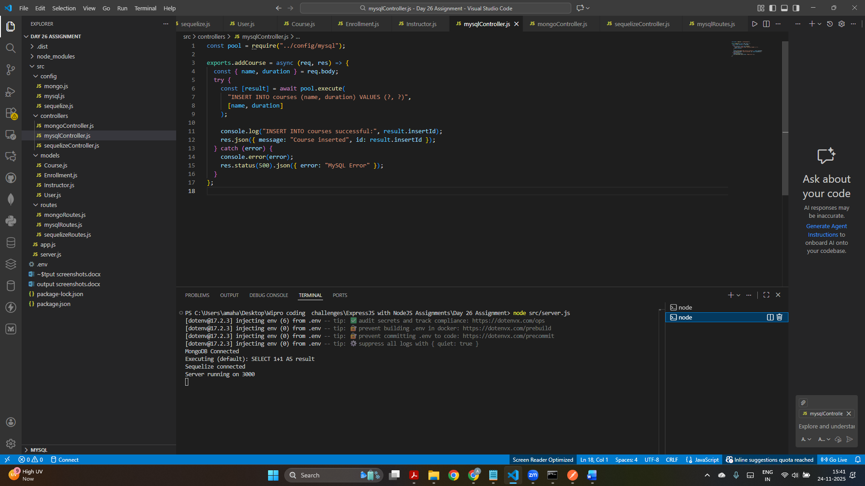
This screenshot shows successful insertion of multiple course records into the MySQL database using your mysqlController.js API logic.

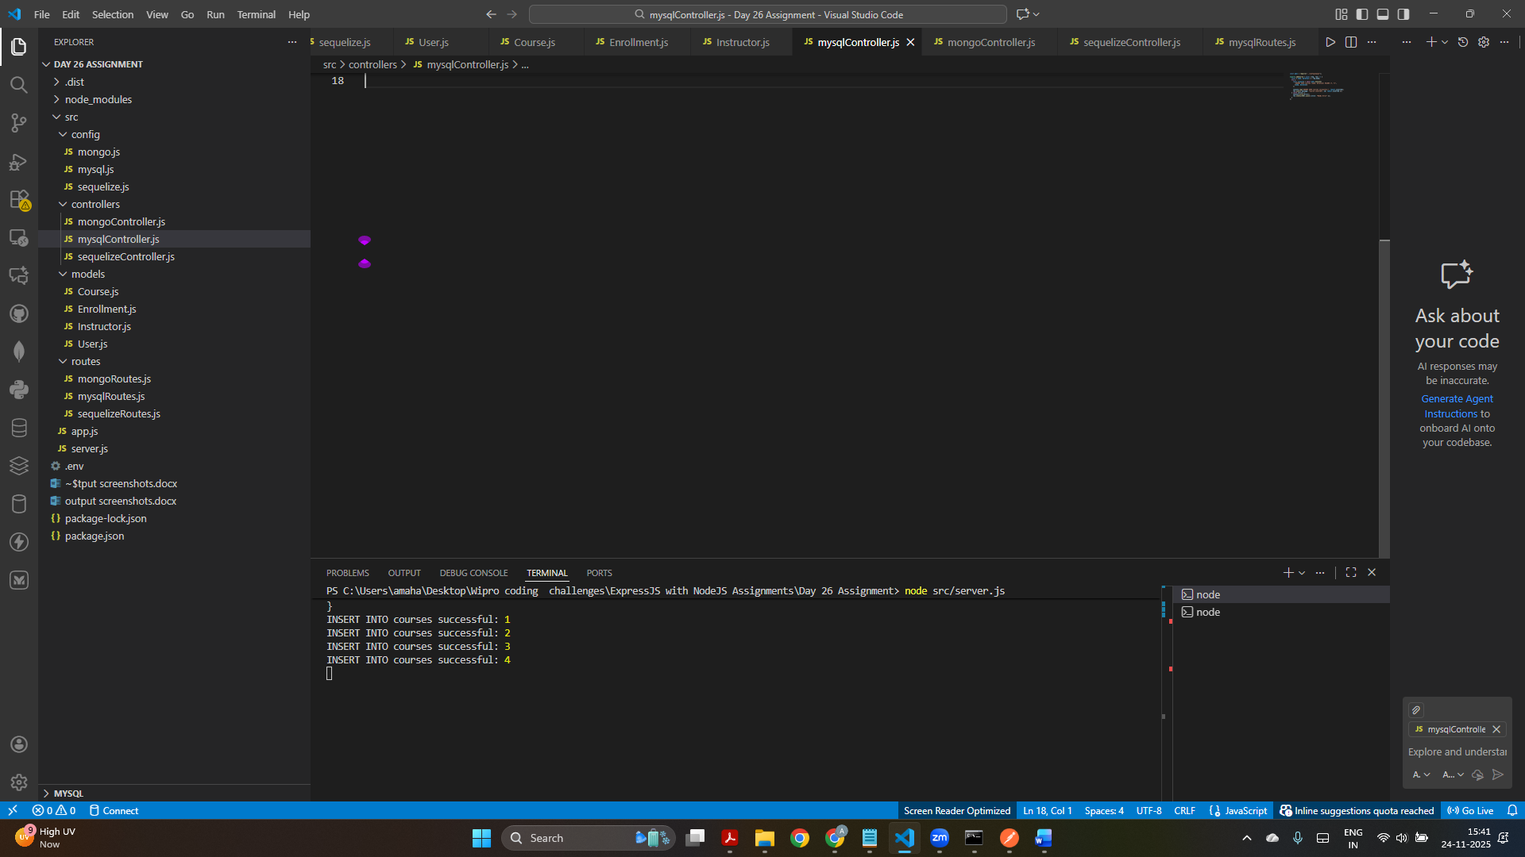
The terminal confirms that several course entries were inserted into MySQL, proving Challenge 1 is working correctly.
Challenge 2:
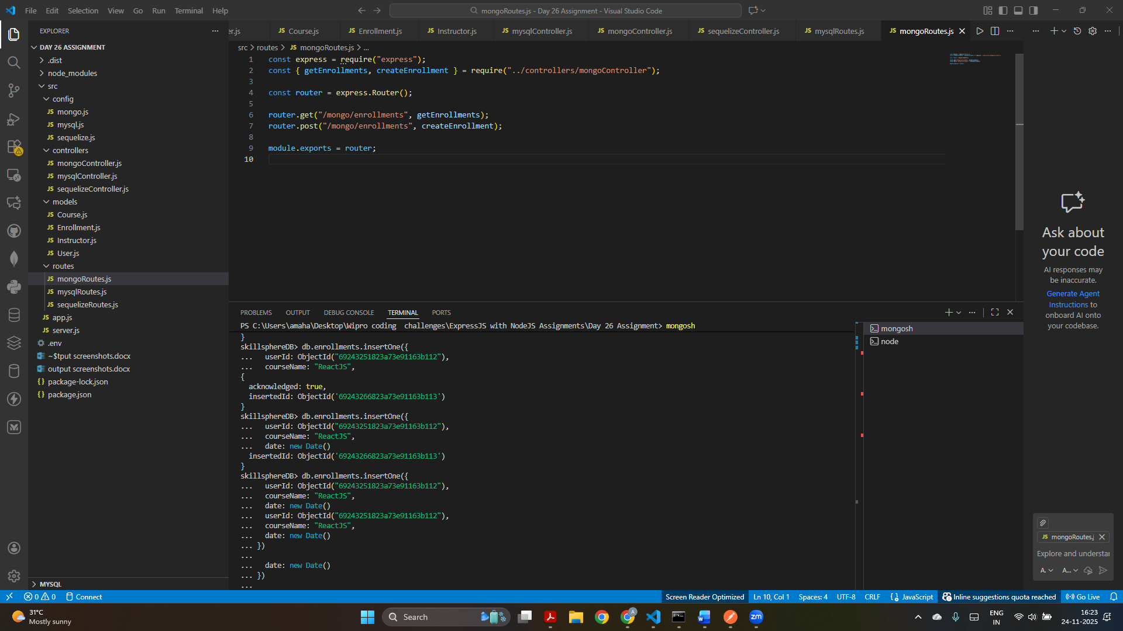
This screen shows the mongoRoutes.js setup along with successful MongoDB enrollment inserts visible in the mongosh terminal, confirming Challenge 2 setup.

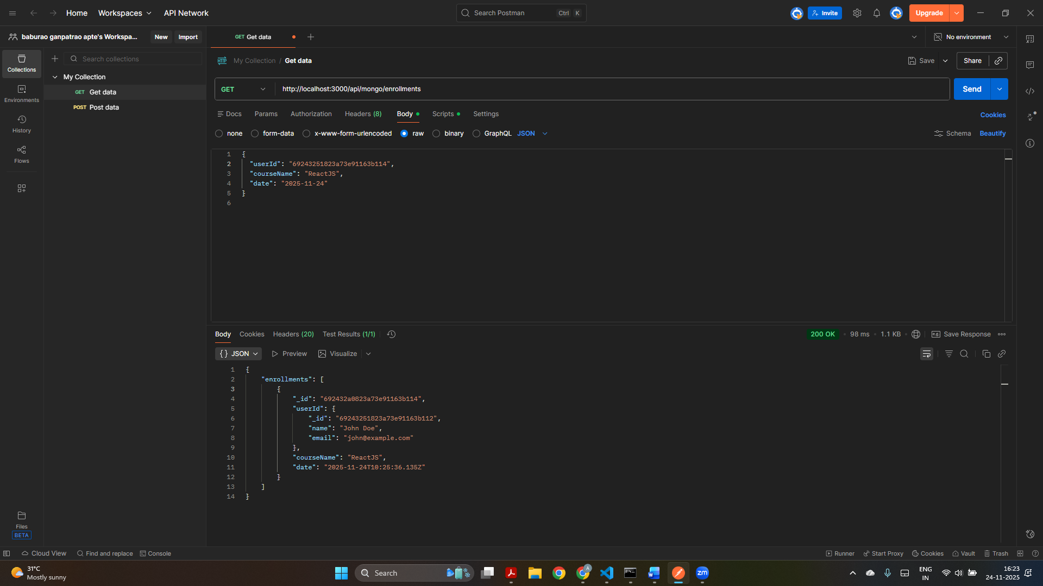
Postman is used to fetch enrollment data from MongoDB, and the response correctly displays user + course enrollment details as required in Challenge 2.

Challenge 3:
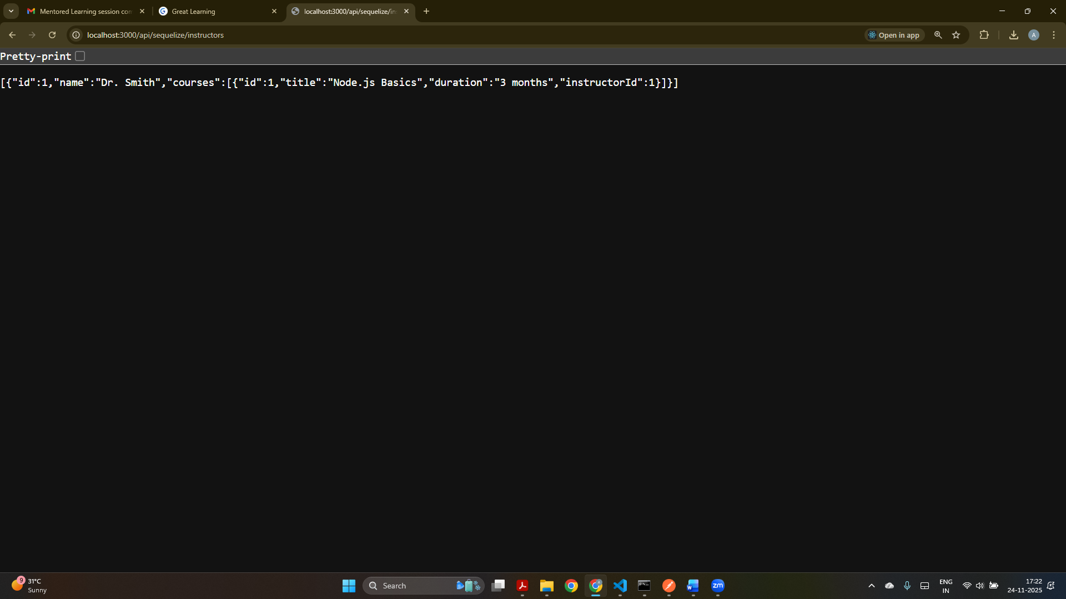
The browser displays the instructor along with their associated courses retrieved via Sequelize ORM, demonstrating that the One-to-Many relationship works.

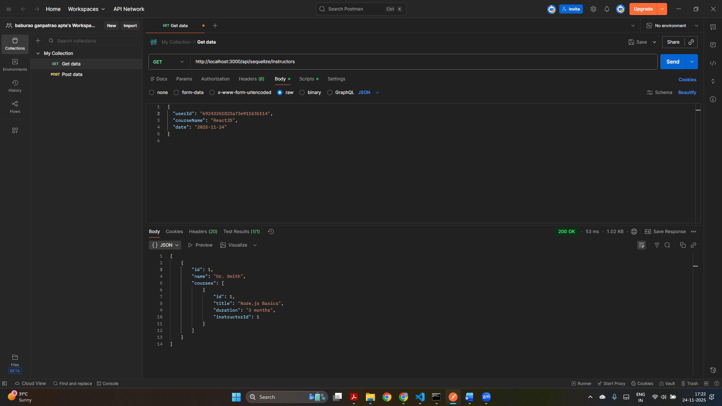
Postman shows the same instructor–courses relationship in structured JSON format, confirming Challenge 3 ORM relationship and query functionality.

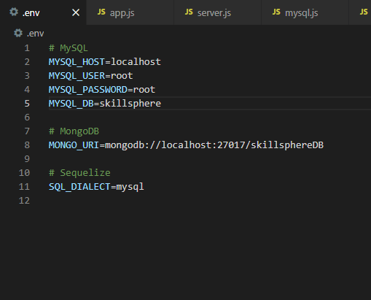
I am uploading a screenshot of .env file and not sharing the .env file for security purposes.

